**IS201 Fundamentals of Computing**

**HOP08B Excel Spreadsheets**

04/10/2020 Developed by Amrutha Vaidyanathan and Apiwat Chuaphan

10/01/2020 Reviewed by Kim Nguyen

Center for Information Assurance (CIAE) @City University of Seattle (CityU)

 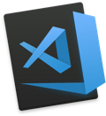

**Before You Start**

* The directory path shown in screenshots may be different from yours.
* Some steps are not explained in the tutorial**.** If you are not sure what to do:
  1. Consult the resources listed below.
  2. If you cannot solve the problem after a few tries, ask a TA for help.

**Learning Outcomes**

Students will be able to:

* Create python programs to get information from the web
* Automate your programs to control websites
* Read and write spreadsheets using Python

**Resources**

* [Automate the Boring Stuff with Python](https://login.proxy.cityu.edu/sso/skillport?context=89288)

**Preparation**

1. In Visual Studio Code, open the private repository generated when you accepted the HOP05 assignment (If you cannot find that repository in your machine, you might have not cloned the repo, if so, please do before proceeding).

**Excel Spreadsheets**

The openpyxl module allows Python programs to read and modify spreadsheets. To install, type this command in the terminal

**>>> pip3 install openpyxl**

1. Notice we have a **example.xlsx**(available under Module 8 folder you cloned).
2. Create a file **read_excel.py**and type the following.

openpyxl.load_workbook() is used to open an existing workbook

>>> In the terminal type **python3 read_excel.py**.

1. Now we will write some to a excel file. Create **write_excel.py** with the following.

>>> In the terminal type **python3 write_excel.py**.

You will get Excel file named “car_data.xlsx” with 2 data.

1. Let’s append more data on the Excel file by updating it as the below screenshot. Use the same python file from the above step.

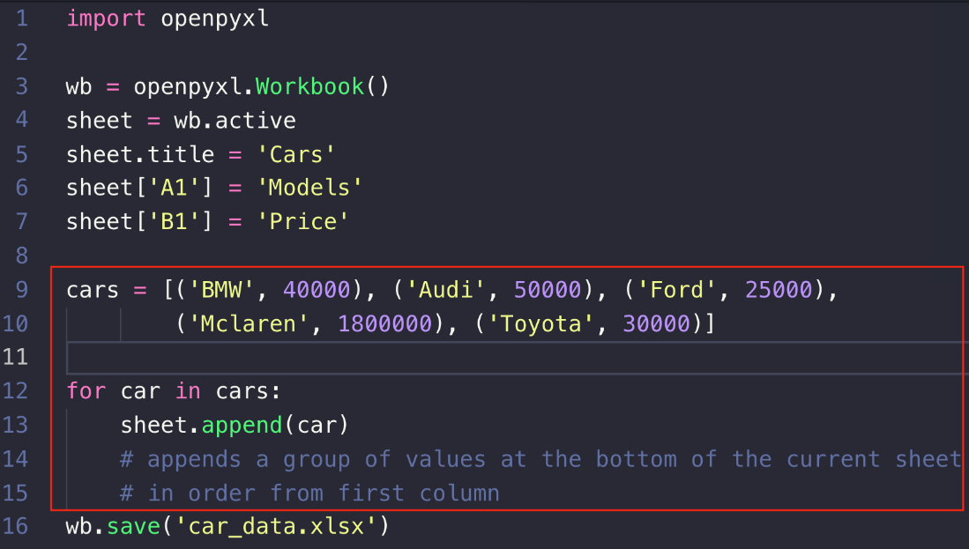

Check the Excel file and see the new data has been added. More info on openpyxl on this [link](https://openpyxl.readthedocs.io/en/stable/api/openpyxl.worksheet.worksheet.html#openpyxl.worksheet.worksheet.Worksheet.iter_cols)

**Push your work to GitHub**

Open the terminal from the VSCode by hitting the “control” + “~” key and type the following command:

>>> git add .

>>> git commit -m “Submission for Module 5 – Your Name”

>>> git push origin master